To create a Student Portal Account please log into this website:
https://txeis23.esc11.net:8443/StudentPortal/login?distid=184907
You will need to create an account, so click on Create Account located just under the Username and Password fields
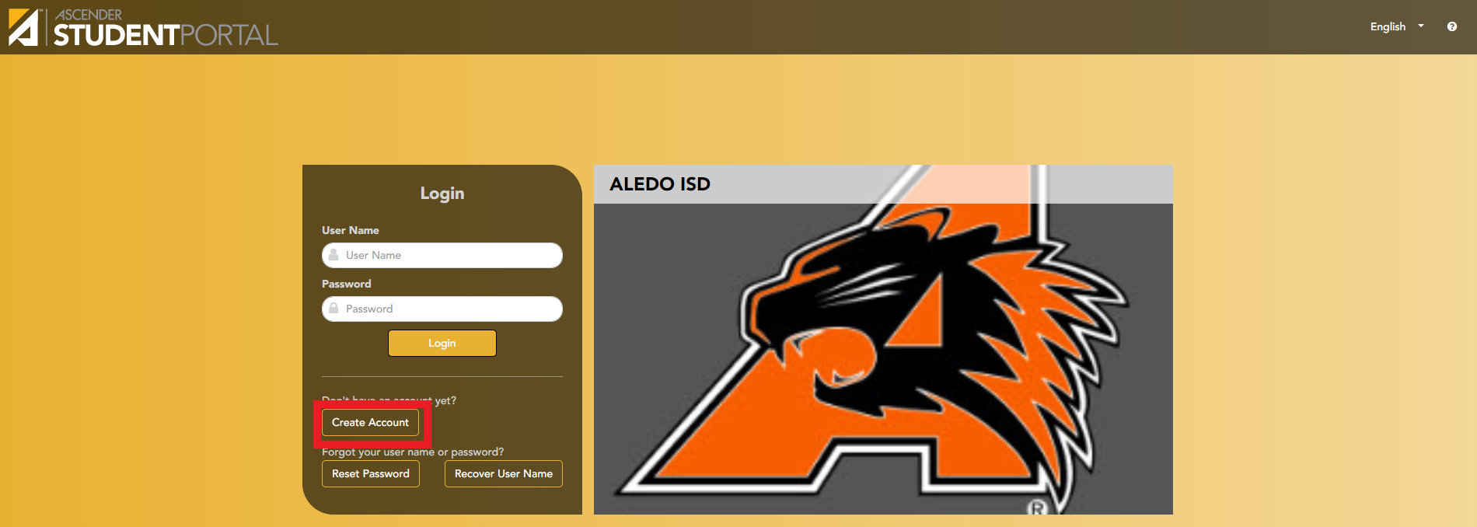
Next you will need your Student ID (same and your lunch number), your birthdate and the last 4 of your Social Security number. If you did not provide your Social Security number to the school at the time you registered, then you will need to contact the school for your “S number last 4”. Once those three fields are entered select Next to move on to the next step.
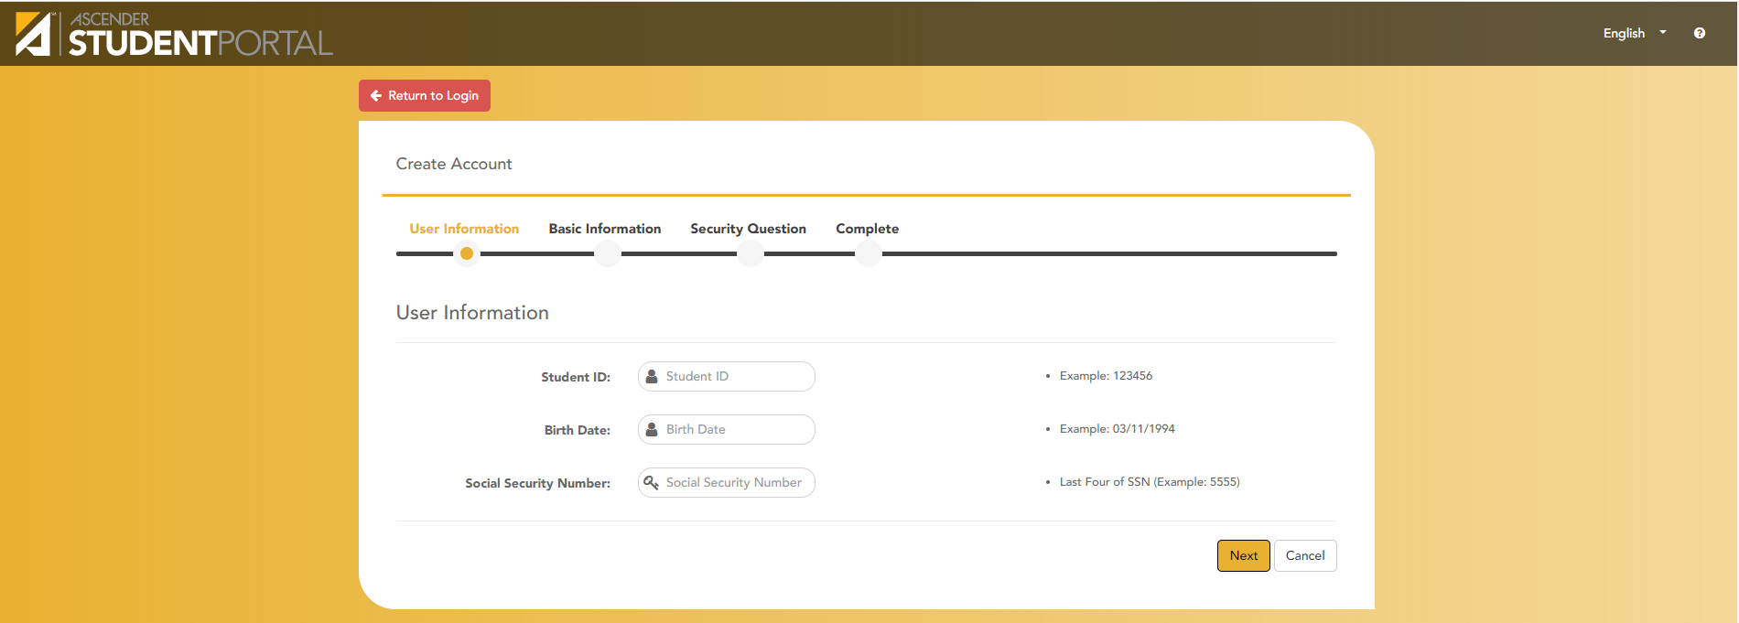

Now it is time to create a Username and Password, please choose something that you will remember, and also follows the requirements! Office staff does not have a way to recover lost or forgotten usernames or passwords. When done, select Next.
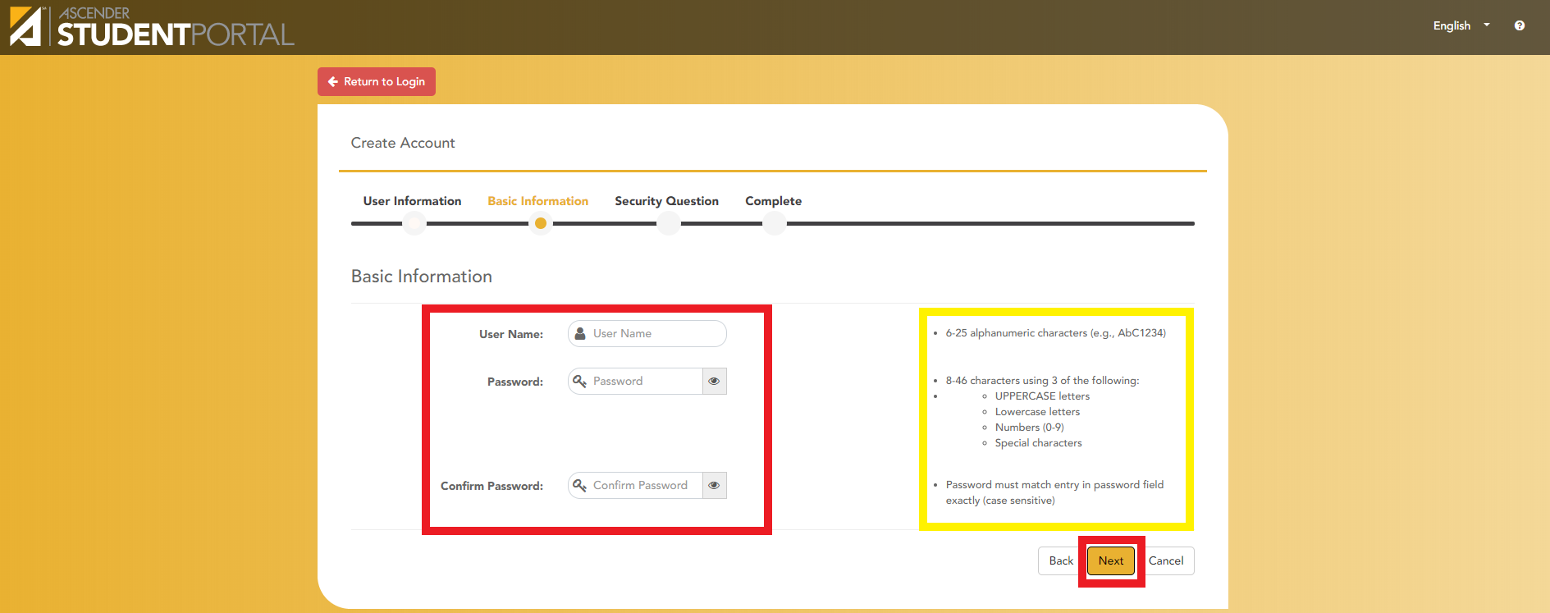
Next it will ask for 3 security questions, which will be asked if you do need your password reset sometime in the future. You can change the questions by clicking the dropdown menu. Each question requires a response. Select Next when done.
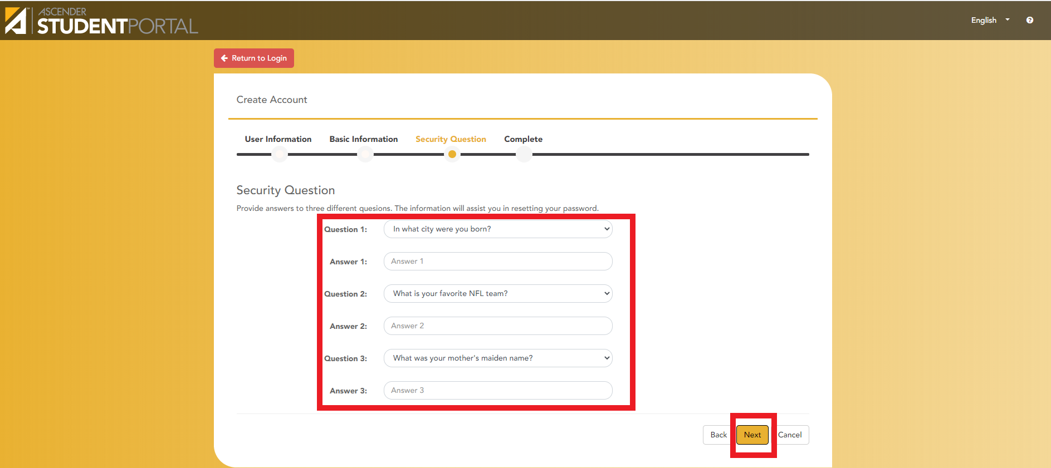
Lastly, you will select Finish and your Student Portal account has been created!
